**Practical no 3B**

**Aim: Perform ARP Poisoning in Windows**

(1) Download and Install cain and able software in your system.For this you need to turn off your firewall.After installation ,open the software you will see a page as displayed below.

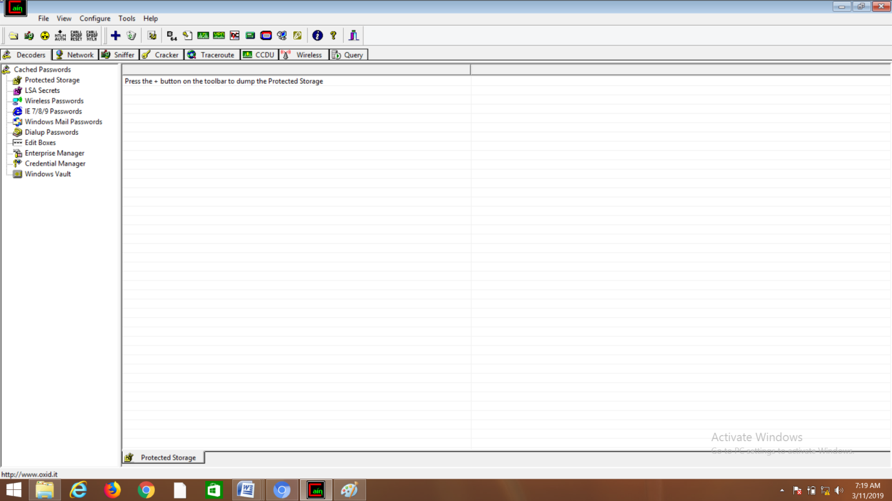

(2)Select "Sniffers" from the top.

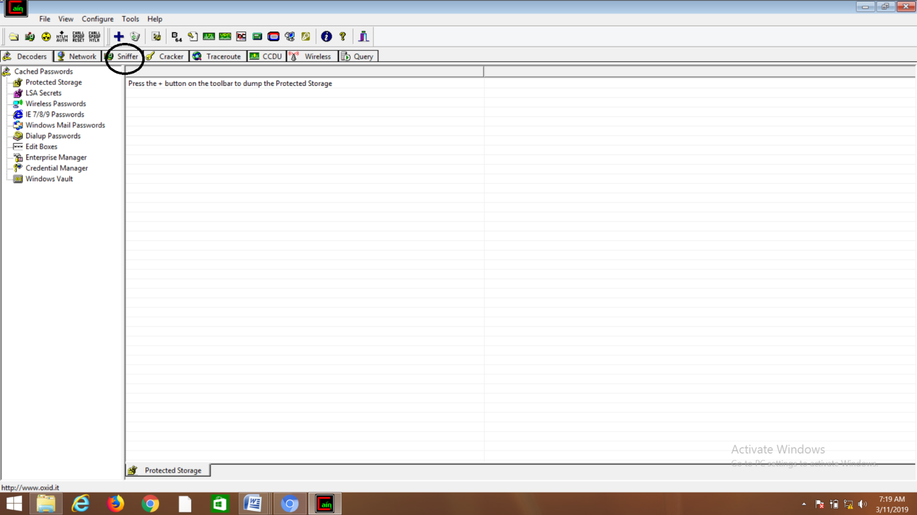

(3) Next to folder icon click on icon name start/stop sniffer. Select device and click on ok.



(4) Next to folder icon click on icon name start/stop sniffer. Select device(Based On Your IP address) and click on ok.

(5) Click on “+” icon on the top. Click on ok.

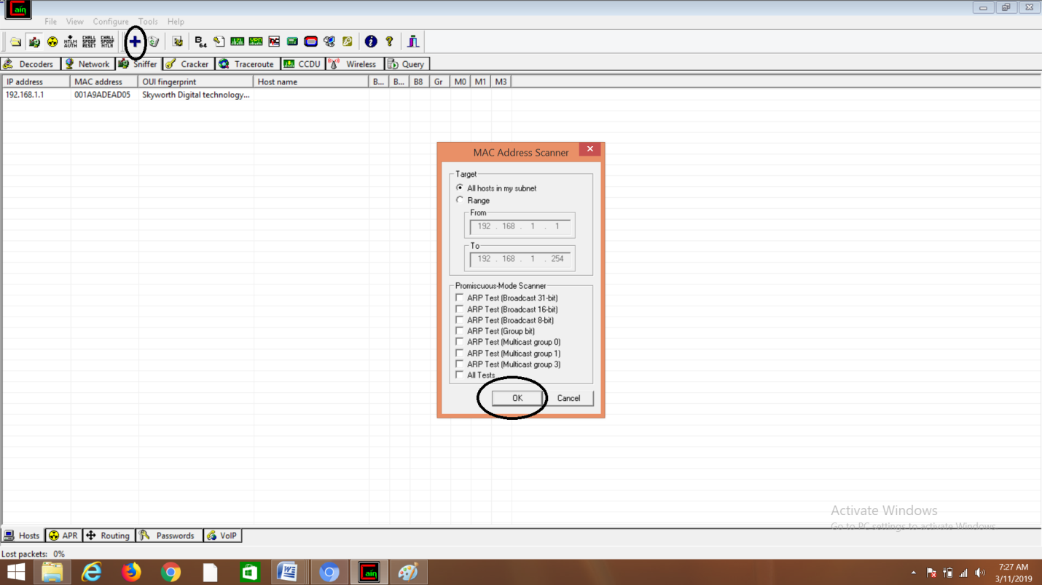

(6)After performing step(5),you will be able to see a list of connected host.

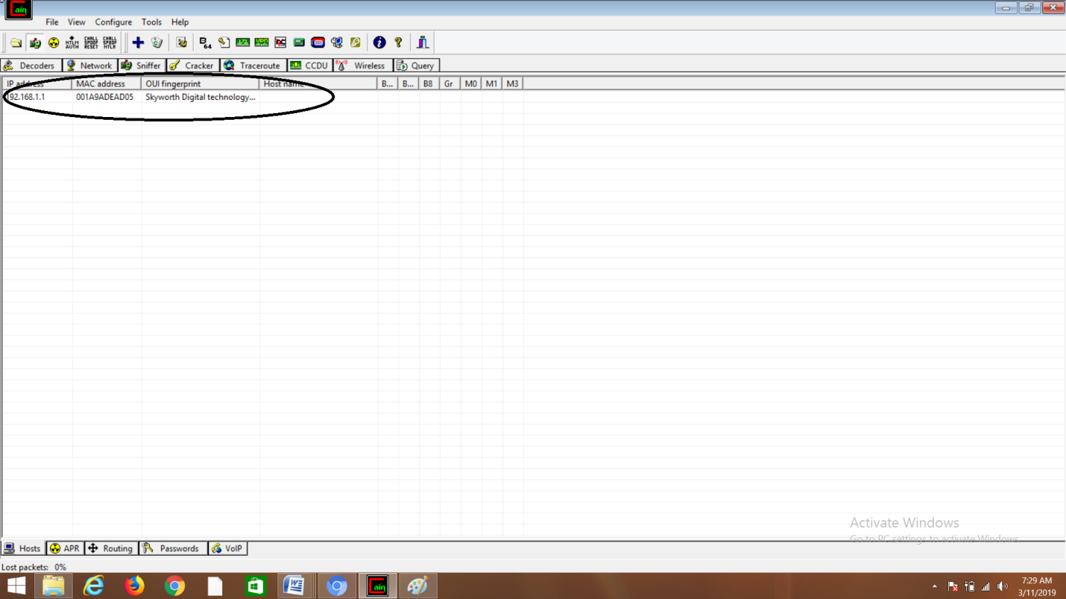

(7)Select "APR"from bottom.



(8) Click on “+” icon at the top.

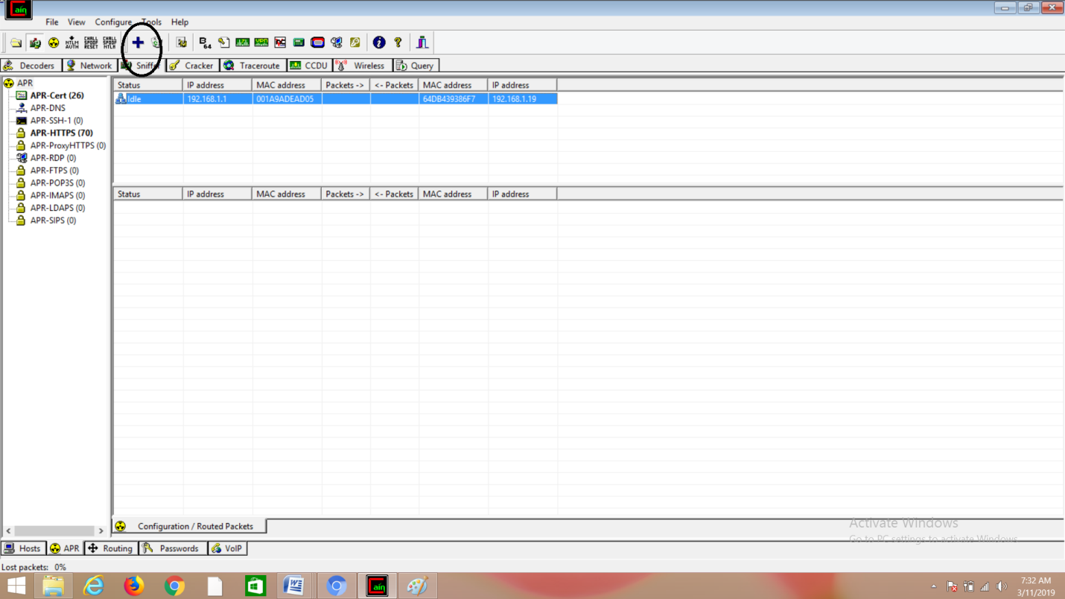

(9) Click on start/stop ARP icon on top.

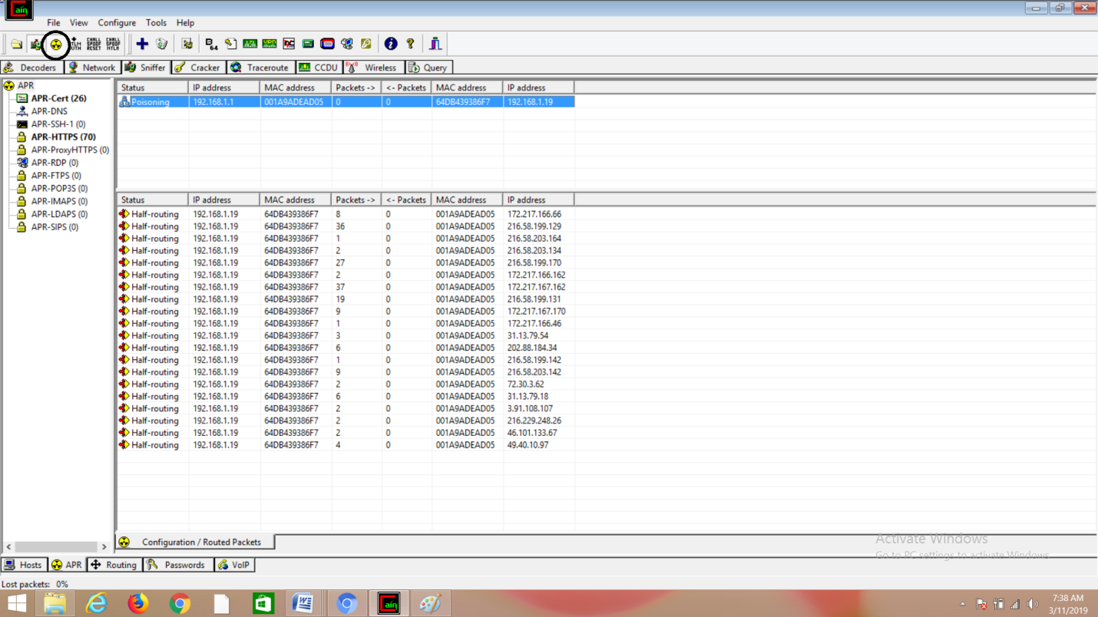

(10) Poisoning the source.

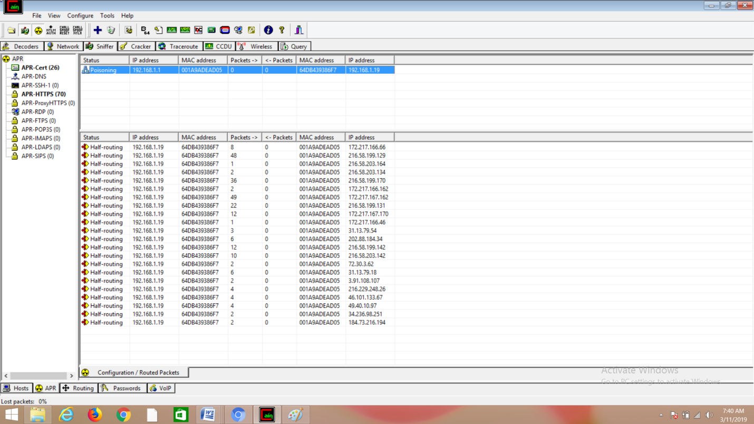

(11) Go to any website on source ip address.

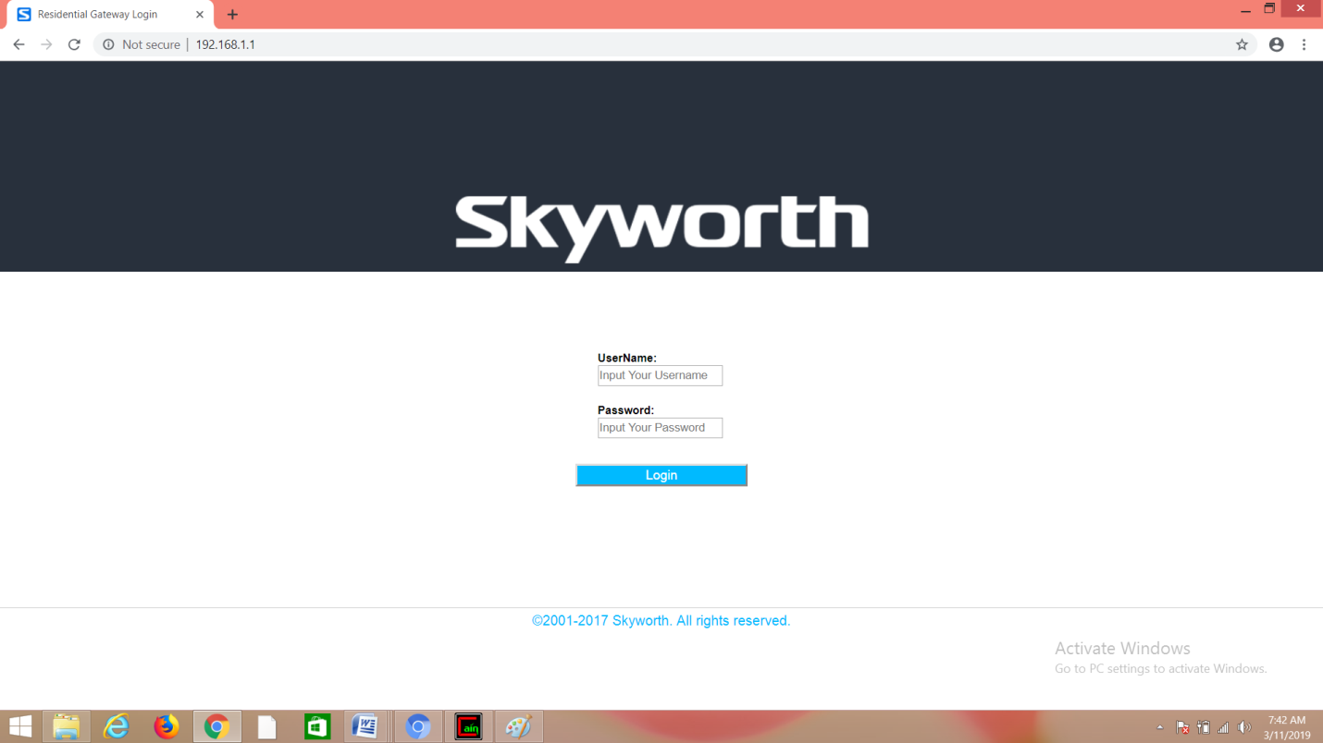

(12)Enter any username and password and click on login.

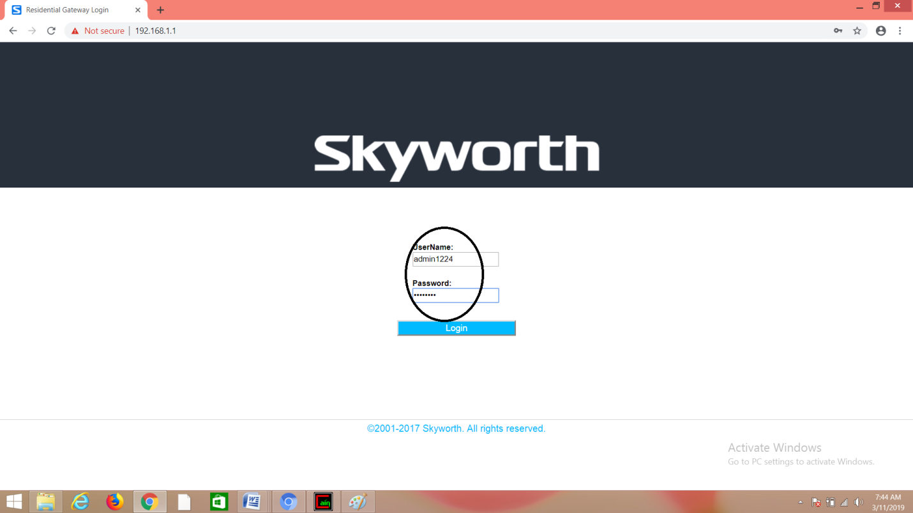

(13)After that click on passwords>HTTP.you will be able to see the username and password which you have entered.

